2026 OFFICE RENOVATION SPECIFICATIONS: 07/14/2026

2026 OFFICE RENOVATION SPECIFICATIONS: 07/14/2026
General Notes:
Project to be broken down into 2 phases.
Phase 1 would be the Training Room and Break Rooms.
Phase 2 would be the rest of the project.

Verify permitting allowed for phasing in various parts of construction to allow shifting of office/plant personnel. At one time Madison Building Inspection stated this should be doable for partial occupancy of different areas in phasing the project. Understanding shifting of personnel in office areas during construction phases.
Verify the ADA compliance requirements.
Any opportunities for better Tornado Area.
PHASE 1- Renovation of Training Room and Break Rooms.
Break Room:
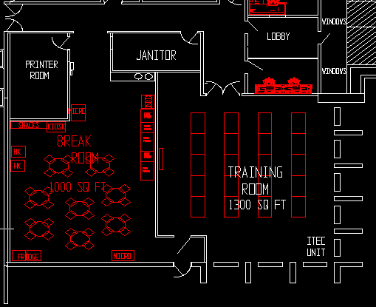
Remove exiting wall between Break Room and Training Room. These areas will be swapped.
Do doors need to be on Break Room?
- Remove all carpet/flooring, ceiling tiles and grid, ceiling insulation, and lighting.
- Remove any existing audio/visual equipment from training room. This will all be replaced.
- This room should have it’s own HVAC. Existing or new Roof top.
- 115v, 20amp duplex receptacles as needed for vending equipment.
- New ceiling tiles to be 2 ft. squares, A.C.T. Ceiling with insulation.
- Floor to be polished concrete unless there are concerns with moisture, then Concrete with an epoxy seal to help retain moisture. Smooth enough surface for ease of cleaning.
- New base trim around perimeter.
- New counter/sink/cabinet.
- Provide water lines to service sinks and Ice maker.
- New LED Lighting 2 x 2.
- New doors to Training Room. Outside door remains if ADA compliant otherwise it needs replaced.
- Receptacle and switches to be Gray with dimmer capabilities.
- Area on wall designated for TV to include power.
- Review paging.
- New Exit Lights.
- Rework sprinkler heads as necessary for room layout. Change to flex with white head and trim.
Training Room:
- Remove all carpet/flooring, ceiling tiles and grid, ceiling insulation, and lighting.
- Remove any existing audio/visual equipment from training room. This will all be replaced.
- This room should have it’s own Bard HVAC. Indoor Comfort Flex to replace I-Tec.
- 115v, 20amp duplex receptacles as needed.
- New ceiling tiles to be 2 ft. squares, A.C.T. Ceiling with insulation.
- Most of the floor to be carpet. Two areas where the units will be polished concrete or an epoxy
seal to help retain moisture. Smooth enough surface for ease of cleaning.
- New base trim around perimeter.
- New LED Lighting 2 x 2.
- New 9’ double doors to Training Room.
- Receptacle and switches to be Gray with dimmer capabilities.
- Area on wall designated for TV to include power.
- Projector to be mounted from ceiling.
- Determine the best way to get power for laptops.
- Blinds on windows.
- Create new hole in block wall for new HVAC.
- Install new 3 Ton inverter model. 460V 3phase on wall.
- Provide the following power where units can be run for training:
(2) 230V-3phase-60hz, 50A service.
(2) 230V-1phase-60hz, 60A service.
The female part of the plug will be mounted on the wall.
- Review paging.
- New Exit Lights.
- Rework sprinkler heads as necessary for room layout. Change to flex with white head and trim.
- Projector will be hung from ceiling. Needs 120V power and ethernet. Picture below.
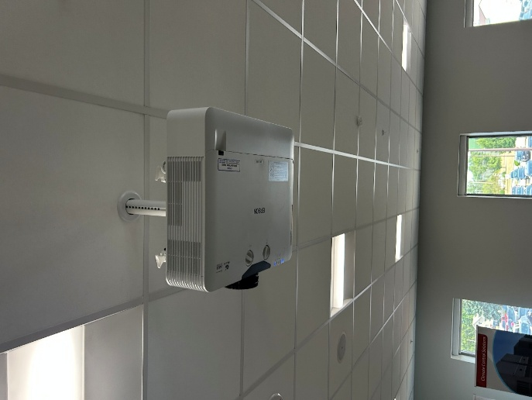
- There will be a tap unit at the front that is powered by power over ethernet.
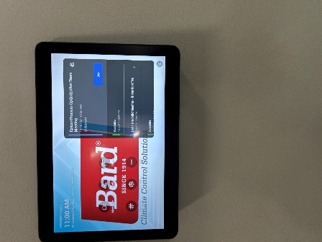
- The rally bar will need (4) 120V receptacle gang box above rally bar in ceiling.
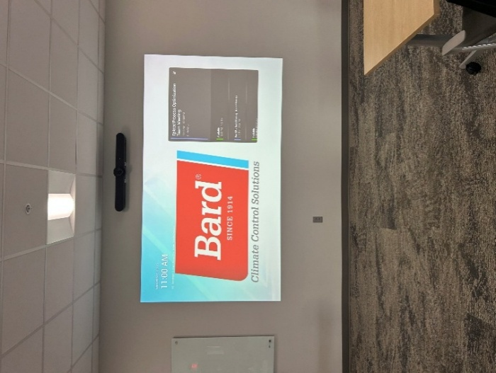
- There will be (4) ceiling mounted Miic Pods hanging from ceiling that goes to Rally Bar.
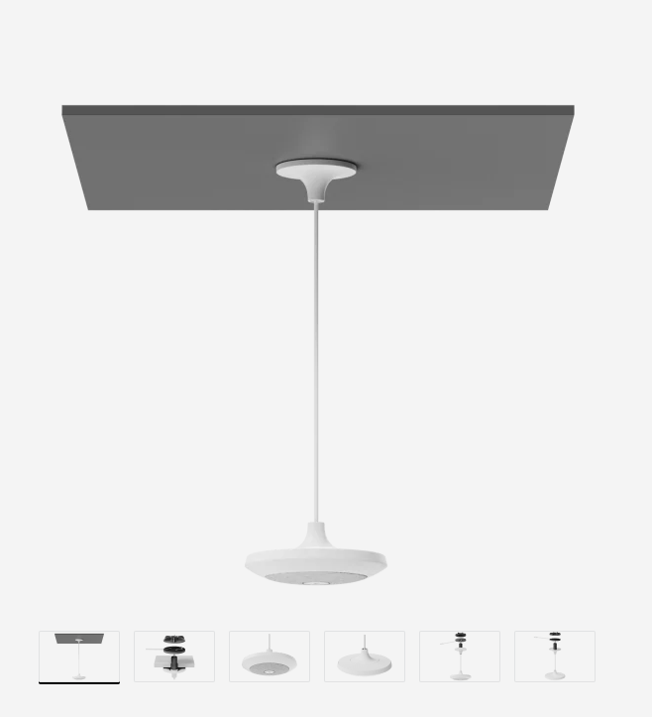

Janitor Room
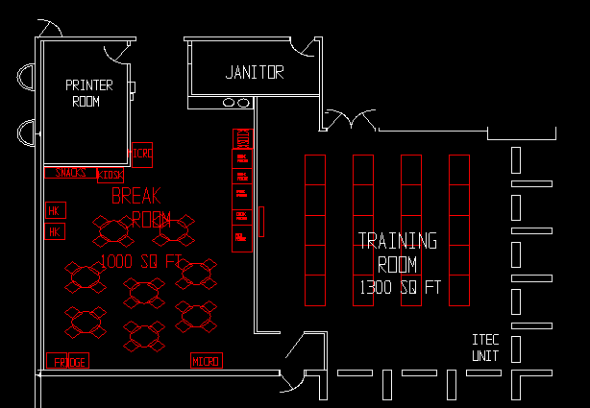
- Remove all carpet/flooring, ceiling tiles and grid, ceiling insulation, and lighting.
- HVAC from one of the new rooftops.
- 115v, 20amp duplex receptacles as needed.
- New ceiling tiles to be 2 ft. squares, A.C.T. Ceiling with insulation.
- Floor to be polished concrete unless there are concerns with moisture, then Concrete with an epoxy seal to help retain moisture. Smooth enough surface for ease of cleaning.
- New water heater.
- Plumbing to be updated as needed for new break room and removal of old break room.
- Evaluate water pressure issues. A diaphragm tank had to be installed at one time to help regulate water pressure as there are issues with multiple flushing of toilets and running faucets simultaneously causing pressure issues with bad vibration of water lines. This tank helped but it is still a problem.
- Install new floor level janitor sink.
- New door with new lock
- Patch and paint any existing walls.
- New base trim around perimeter.
- New LED lighting 2 x 2.
- Receptacles and switches to be Gray.
- New base trim around
- Rework sprinkler heads as necessary for room layout. Change to flex with white head and trim.

Printer Room:
- Remove all carpet/flooring, ceiling tiles and grid, ceiling insulation, and lighting.
- HVAC from one of the new rooftops.
- 115v, 20amp duplex receptacles as needed.
- New ceiling tiles to be 2 ft. squares, A.C.T. Ceiling with insulation.
- Floor to be polished concrete unless there are concerns with moisture, then Concrete with an epoxy seal to help retain moisture. Smooth enough surface for ease of cleaning.
- New door with new lock
- Patch and paint any existing walls.
- New base trim around perimeter.
- New LED lighting 2 x 2.
- Receptacles and switches to be Gray.
- Rework sprinkler heads as necessary for room layout. Change to flex with white head and trim.

Restrooms:
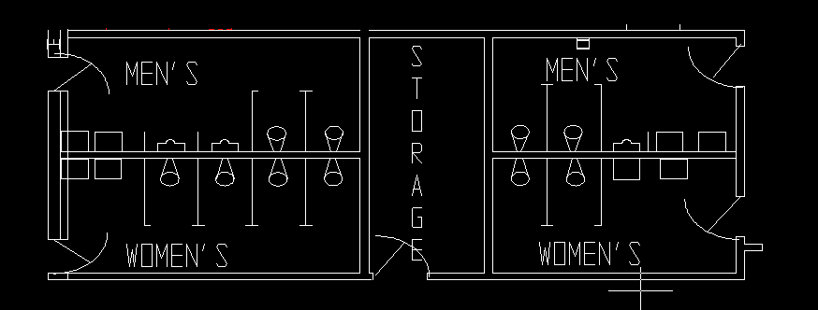
- Demo all restrooms completely.
- New tile on floors and walls. Larger size than current for ease of cleaning.
- New restroom partitions to match the new restrooms.
- New restroom fixtures. Sinks, toilets, urinals, mirrors, grab bars, dispensers, etc.
- Replace all cast iron vent piping with PVC.
- Grind and remove the concrete in the restrooms as required to bring the surface level with the original concrete slab. The cast-iron drain piping was replaced with PVC approximately two years ago, but the replacement concrete was poured flush with the finished tile instead of the original slab. Existing PVC drains are to remain unless damaged during the work.
- New exhaust fans external to building preferable.
- HVAC from one of the new rooftops.
- 115v, 20amp duplex receptacles as needed.
- New ceiling tiles to be 2 ft. squares, A.C.T. Ceiling with insulation.
- New base trim around perimeter.
- New LED lighting 2 x 2.
- Receptacles and switches to be Gray.
- Rework sprinkler heads as necessary for room layout. Change to flex with white head and trim.
Storage Room:
- HVAC from one of the new rooftops.
- 115v, 20amp duplex receptacles as needed.
- New ceiling tiles to be 2 ft. squares, A.C.T. Ceiling with insulation.
- New base trim around perimeter.
- New LED lighting 2 x 2.
- Receptacles and switches to be Gray.
- New door.
- Rework sprinkler heads as necessary for room layout. Change to flex with white head and trim.
Receptionist/Lobby/Hotel Office:
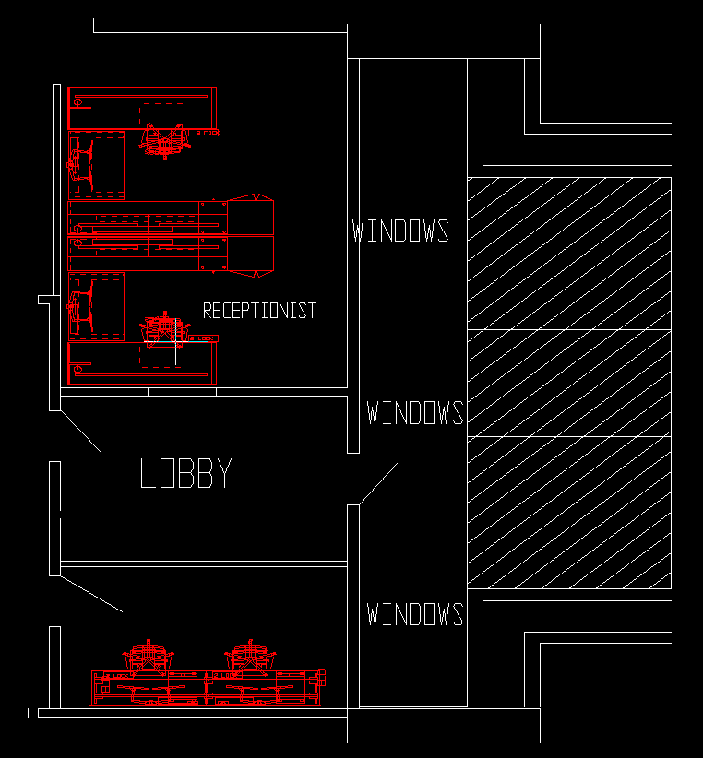
- Remove all carpet/flooring, ceiling tiles and grid, ceiling insulation, and lighting.
- Demo walls.
- Front windows to be replaced with front lobby door relocated.
- Frame new walls.
- HVAC from one of the new rooftops.
- 115v, 20amp duplex receptacles as needed.
- New ceiling tiles to be 2 ft. squares, A.C.T. Ceiling with insulation.
- Flooring to be new carpet.
- New door with ½ glass and new lever lock on hotel office.
- New solid door and new lever lock on lobby door to plant.
- Visitor Office Door and the Hallway Door and the Inside Lobby Door have Ackerman Security System Contact on door/door frame that will need to be switched to the new doors.
- Patch and paint any existing walls.
- New base trim around perimeter.
- New LED lighting 2 x 2.
- Receptacles and switches to be Gray.
- Rework sprinkler heads as necessary for room layout. Change to flex with white head and trim.

Front Two Offices and Conference Room:
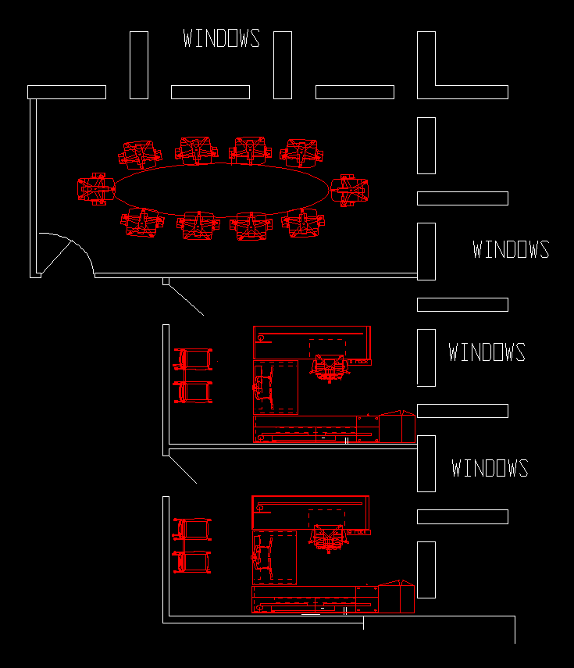
- Remove all carpet/flooring, ceiling tiles and grid, ceiling insulation, and lighting.
- Demo walls.
- Frame new walls.
- HVAC from one of the new rooftops.
- 115v, 20amp duplex receptacles as needed.
- New ceiling tiles to be 2 ft. squares, A.C.T. Ceiling with insulation.
- Area on wall designated for TV to include power.
- Flooring to be new carpet.
- New doors with ½ glass with new lever locks. These will include side windows as shown below.
- Patch and paint any existing walls.
- New base trim around perimeter.
- New LED lighting 2 x 2.
- Receptacles and switches to be Gray.
- Rework sprinkler heads as necessary for room layout. Change to flex with white head and trim.
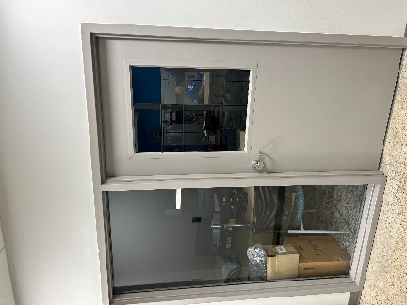
Open Cubicle Area:
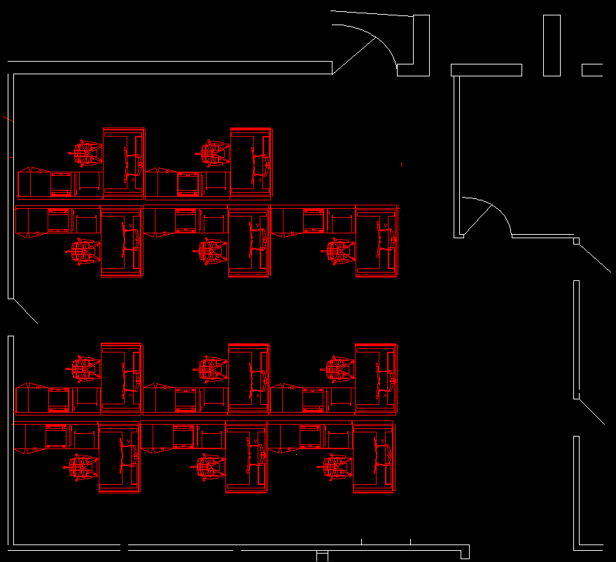
- Remove all carpet/flooring, ceiling tiles and grid, ceiling insulation, and lighting.
- Remove all partitioning.
- HVAC from one of the new rooftops.
- Frame new walls.
- 115v, 20amp duplex receptacles as needed.
- New ceiling tiles to be 2 ft. squares, A.C.T. Ceiling with insulation.
- Flooring to be new carpet and polished concrete.
- New doors with new lock
- Patch and paint any existing walls.
- New base trim around perimeter.
- New LED lighting 2 x 2.
- Receptacles and switches to be Gray.
- Rework sprinkler heads as necessary for room layout. Change to flex with white head and trim.

HR Offices:
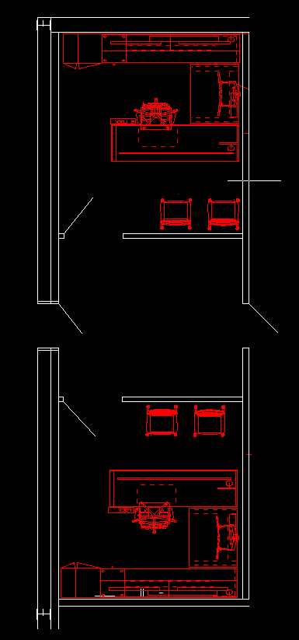
- Remove all carpet/flooring, ceiling tiles and grid, ceiling insulation, and lighting.
- HVAC from one of the new rooftops.
- Frame new walls.
- 115v, 20amp duplex receptacles as needed.
- New ceiling tiles to be 2 ft. squares, A.C.T. Ceiling with insulation.
- Flooring to be new carpet in offices and polished concrete in waiting area.
- New door with ½ glass and new lever lock on the (2) HR offices.
- Patch and paint any existing walls.
- New base trim around perimeter.
- New LED lighting 2 x 2.
- Receptacles and switches to be Gray.
- Rework sprinkler heads as necessary for room layout. Change to flex with white head and trim.

